Combination of PI Tech member’s schedules:

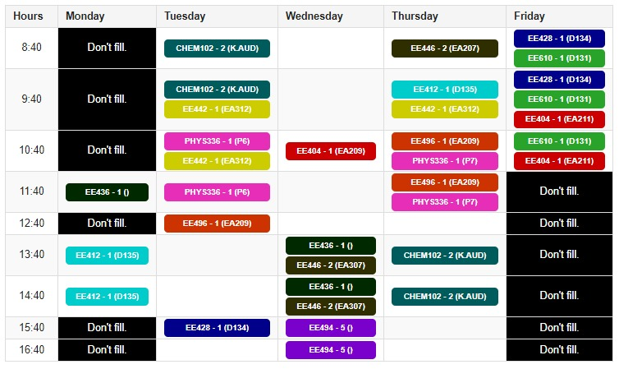

İrem Coşkun’s schedule:

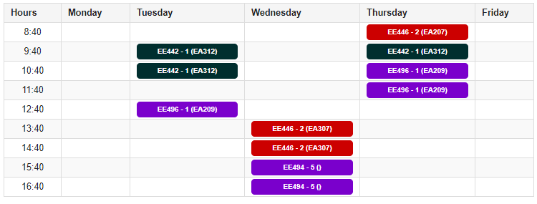

Furkan Bahadır Elik’s schedule:

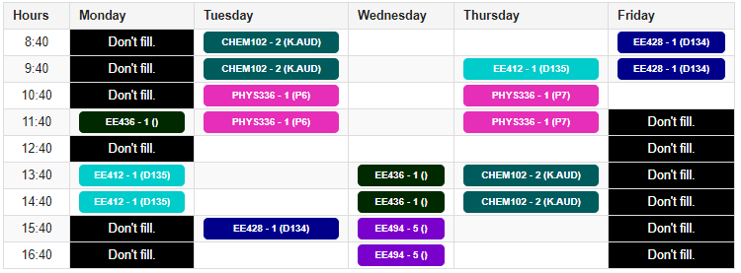

Berkay Goksu’s schedule:

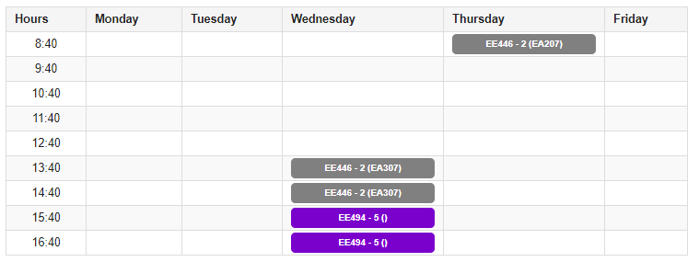

Fatma Nur Arabacı’s schedule:

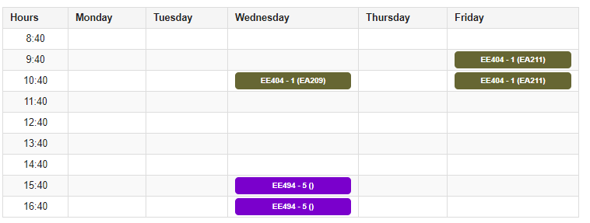

Aycan Beyenir’s schedule:

